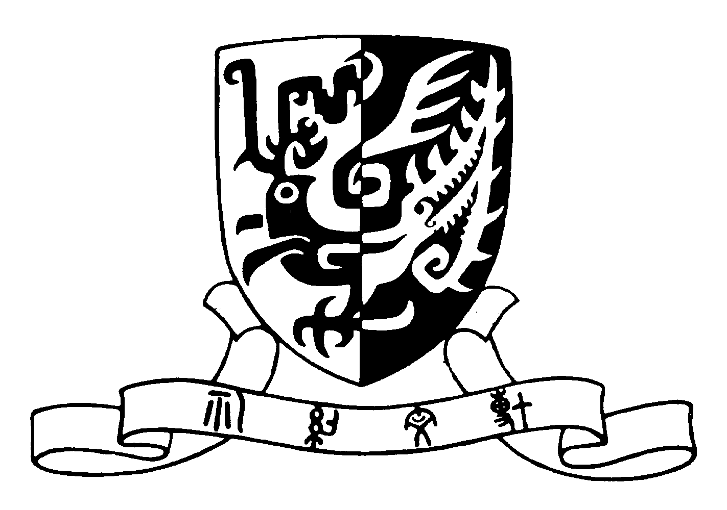
The Chinese University of Hong Kong

School of Life Sciences

Life Sciences Seminar Series
2016 – 2017

The Origins of Death and Sex

by

Professor Alex Sai-Kit Law,
Professor, Nanyang Technical University,
Singapore

on

March 16, 2017
(Thursday)

at

12:30 – 1:15 pm

at

L2, Science Centre

The Chinese University of Hong Kong

ALL ARE WELCOME

